Star-shot Test on Elekta

# Purpose

This procedure lists the steps involved in performing starshot tests for gantry, couch, collimator, and MLC on Elekta. The starshot test verifies coincidence of beams shot at different angles.

# Steps

1. Obtain a piece of film from the cabinet under the printer beside the Tomo console.

## In Elekta treatment room

1. Obtain the cart from the Engineers Room in either Elekta-1 or Elekta-2.
2. Remove the couch head.
3. Set up the solid water and film.
   1. Tape the film to a 6 cm block of solid water.
   2. Add a 4 cm block. The film should be between the two blocks.
   3. Orient the setup according to the starshot that you are performing. (See the end of this document for photos.)
      * Gantry: Film is parallel to the walls in the G-T direction.
      * Couch: Film is parallel to the floor and ceiling.
4. Scoot the solid water setup to the end of the couch.
5. Align the solid water to the X and Y lasers.
6. Align the solid water to 100 SSD. In other words, align the Z laser to the top of the solid water. If the laser is aligned, you should see dust on the top of the solid water.
7. Using the hand pendant, set the gantry and collimator to 0°.
8. If you are performing a couch starshot, retract the kV arm and imaging panel, if necessary, using the XVI hand pendant.
9. If you are performing a couch starshot, rotate the couch from -90° to 90° to ensure that it will not hit any items in the treatment room.

## At Elekta console

1. Open linac software in Service Mode.
   * If linac is not currently on, follow steps in T:\Physics - T\PROCEDURES\Elekta\Startup & Shutdown\Elekta Startup.
   * If linac is currently on and in Clinical Mode:
     1. Click *Exit*.
     2. Click the icon to switch modes (bottom right corner).
     3. Log in to Service Mode with username and password *service*.
2. Click the Service Functions icon.

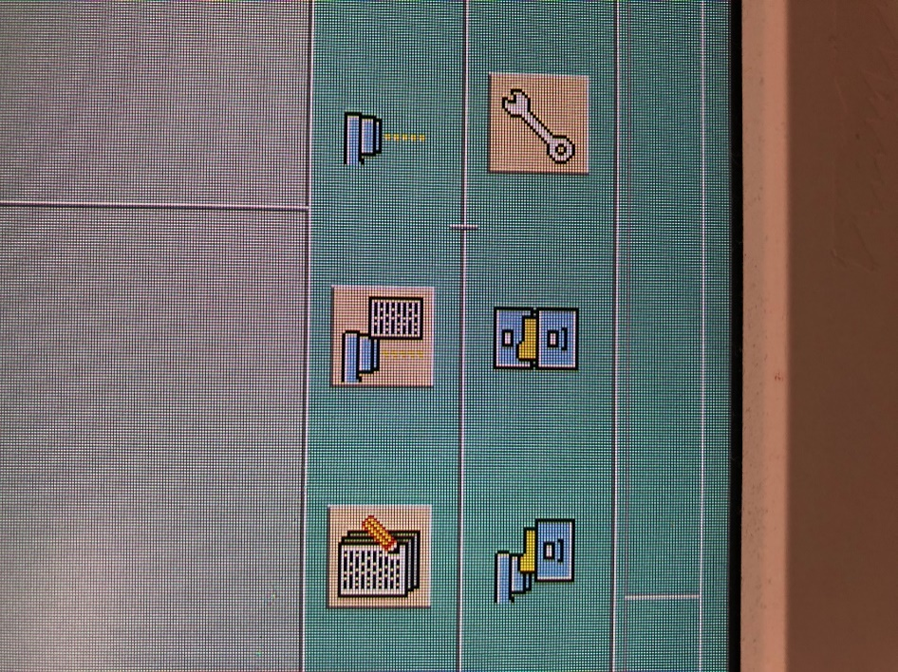

1. Click the Deliver Stored Beam icon.

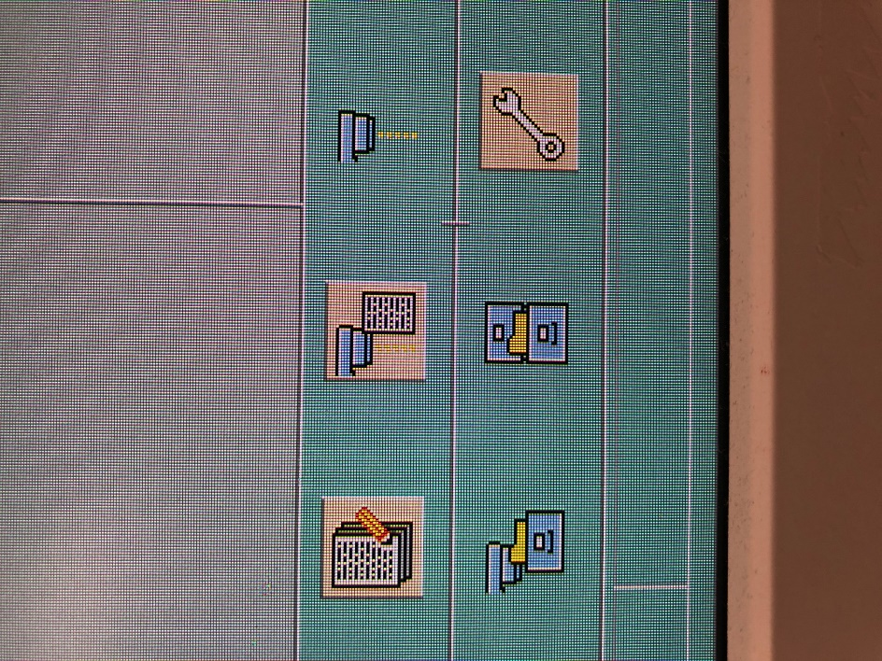

1. Select the correct sequence from the *Sequences* dropdown according to the starshot that you are performing:
   1. Gantry: Gantry Star
   2. Couch: Couch Star

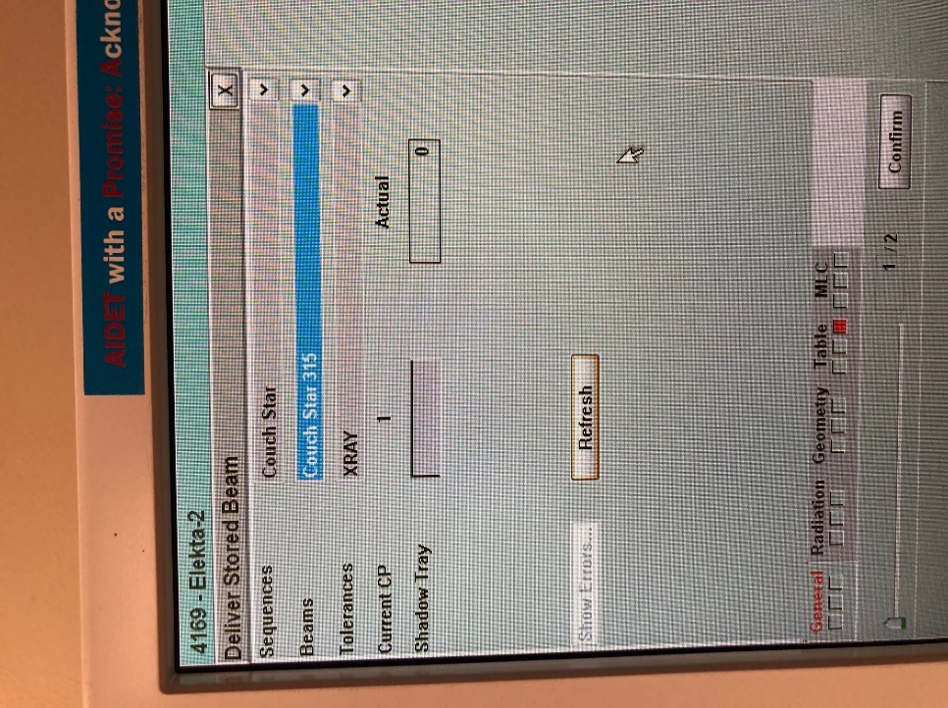

1. If you see a red square on any of the tabs (as in the above photo), navigate to that tab and use the Enable + ASU buttons on the console to correct the settings. Notice that in the below photo, the red appears because the couch should be at 0° for this beam, but it is currently at -45°.

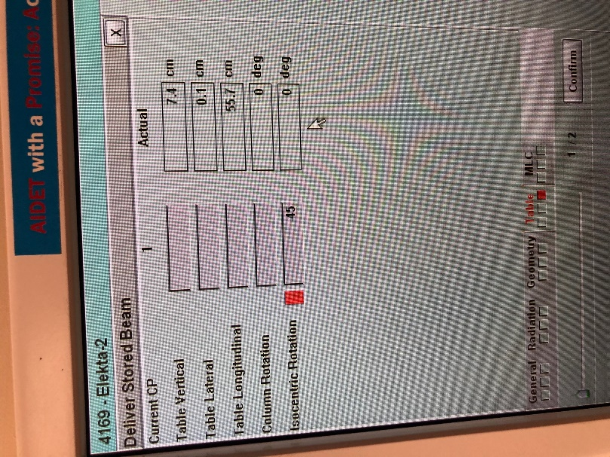

Hold the buttons until the number stops changing.

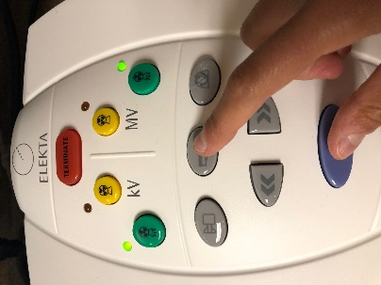

The red should disappear.

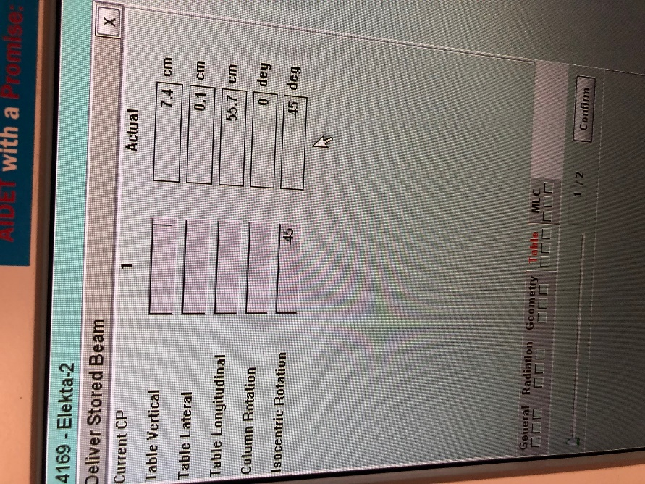

1. Click *Confirm*. You should see the below screen.

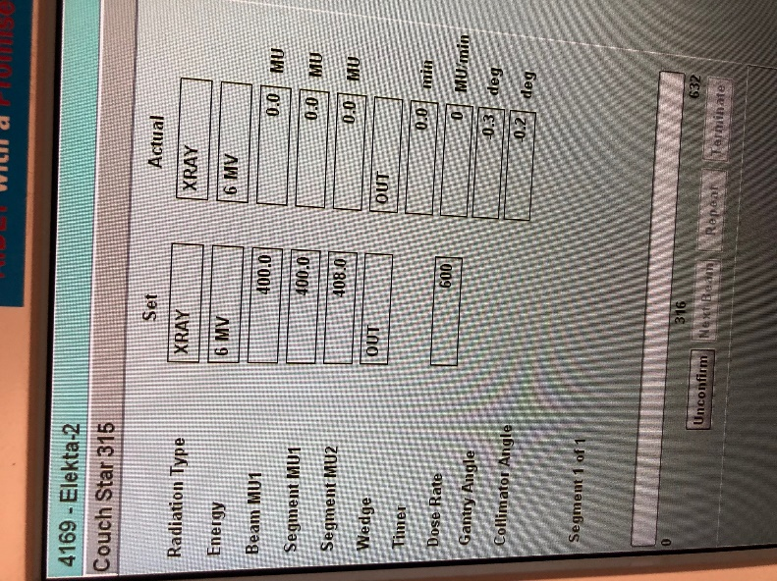

1. Wait until the top stripe at the bottom left of the screen says “Ready to Start.”

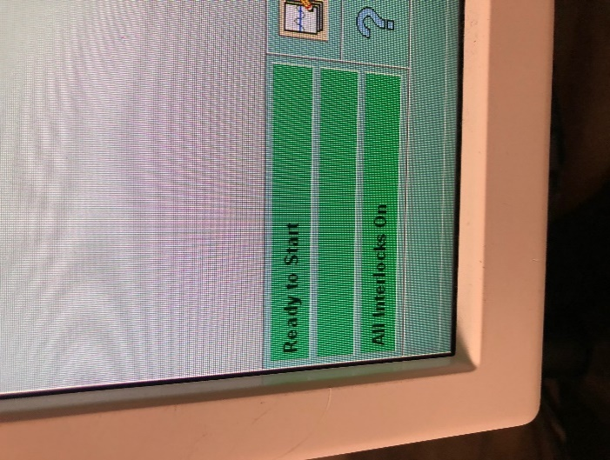

Then press the green MV button on the console.

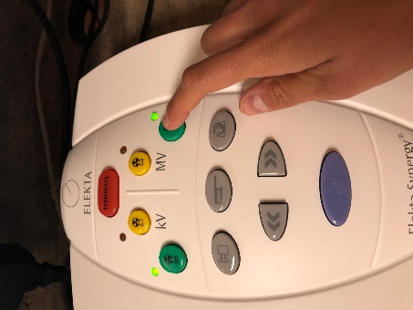

1. When the radiation finishes, click *Next Beam*.

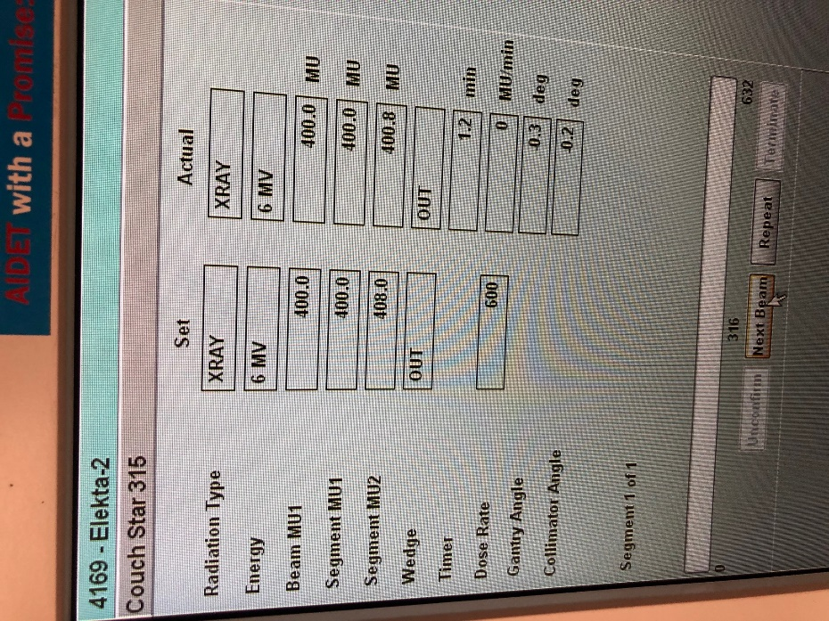

The next beam in the sequence should be selected from the *Beams* dropdown.

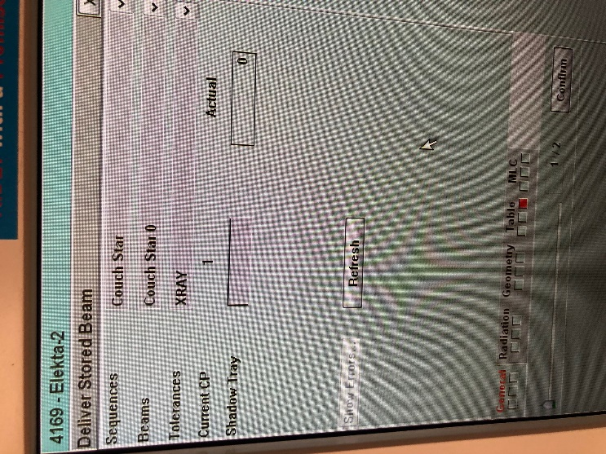

1. Repeat steps (15)–(18) for the remaining beams in the sequence.
2. Log out of Service Mode by clicking the Log Off button and then clicking *Yes*.

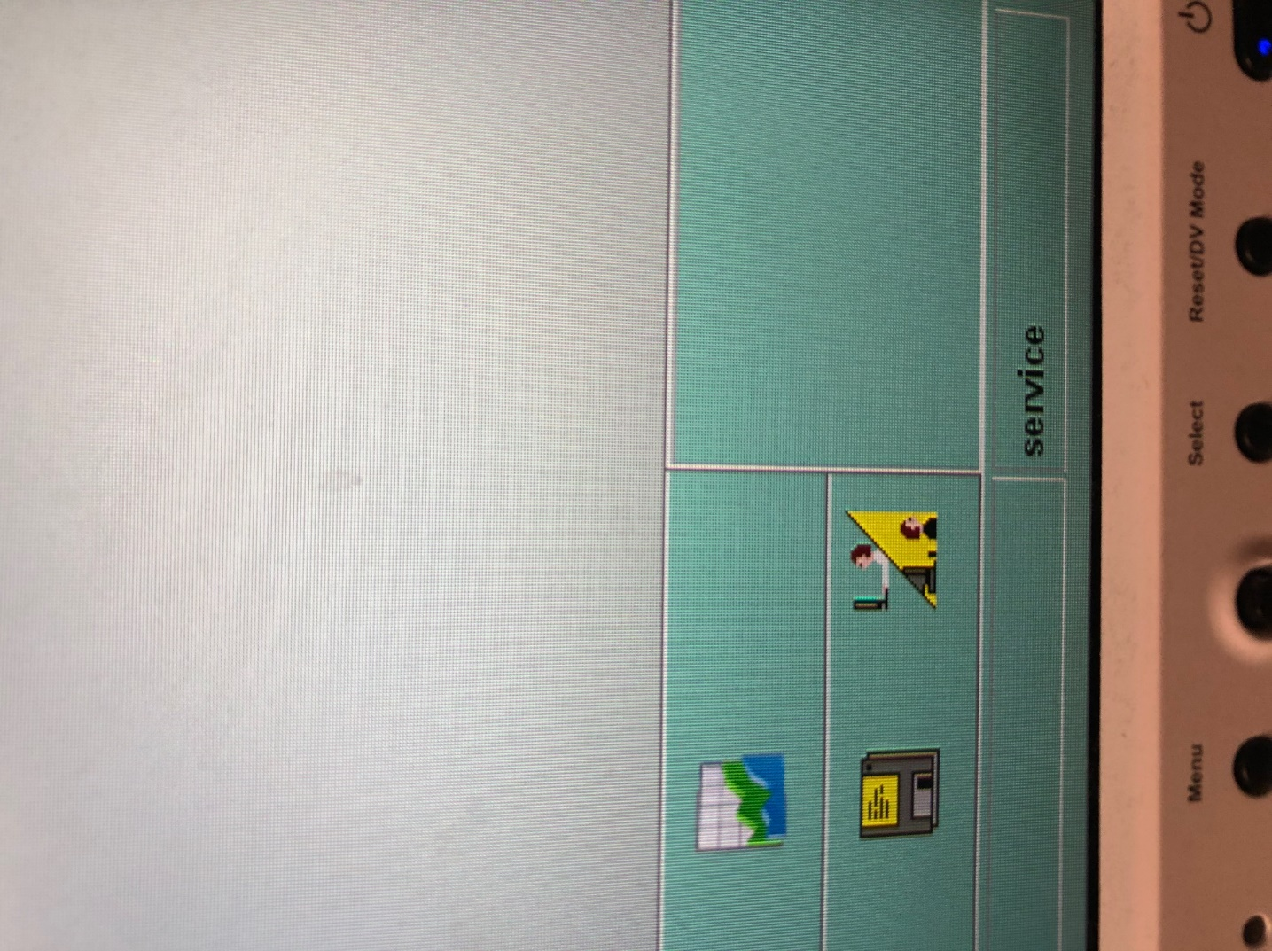

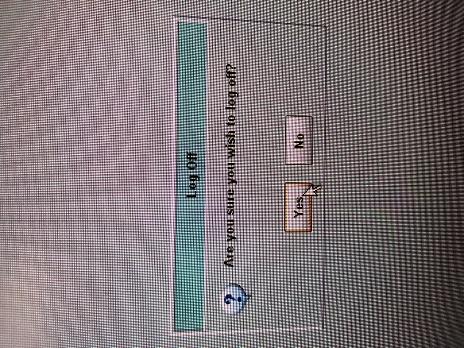

1. If necessary, log back into Clinical Mode using username and password *super*.

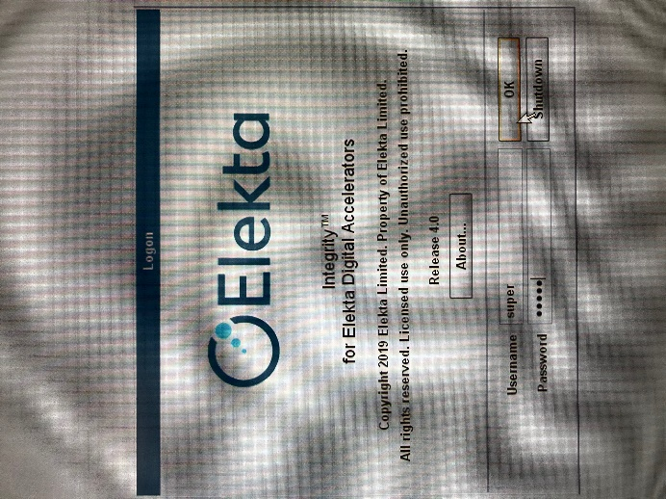

## In Elekta treatment room

1. Set gantry and collimator to 0°.
2. Un-tape film from solid water, but do not remove film from packaging!
3. Put the solid water back on the cart, and return the cart to the Engineers Room.

## In dark room

1. Close the lid on the developer. Turn on the developer with the red button on the side. Turn the leftmost knob to *OPEN*. Press the green *READY* button. Wait ~20 minutes for the developer to warm up.

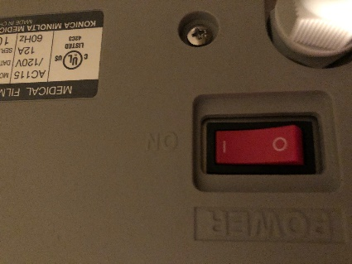 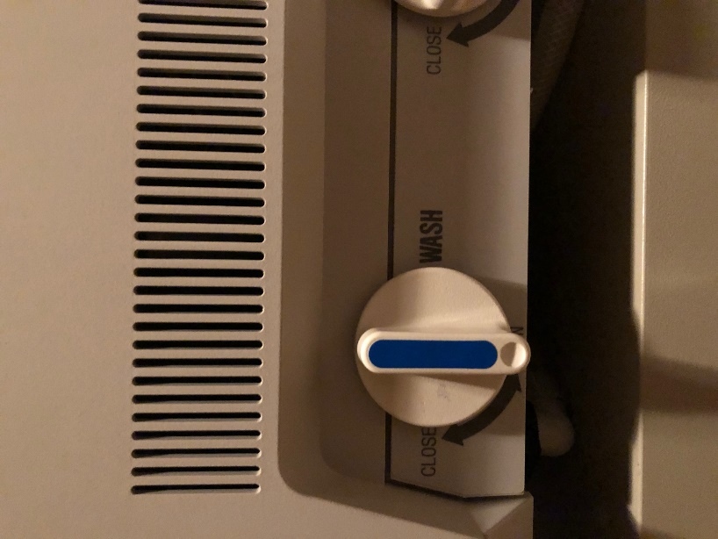

1. Turn off lights. Leave infrared lights on.
2. Insert test film (from shelf).
3. When all three lights come on, rip the tab off the film packaging. Remove film from packaging. Insert film into developer.

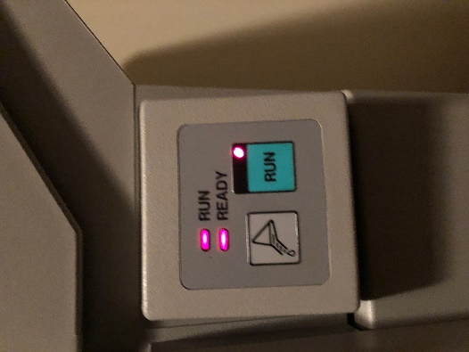

1. When the film comes out of the developer, turn off the developer, turn the leftmost knob to *CLOSE*, open the lid, and turn off all room lights.

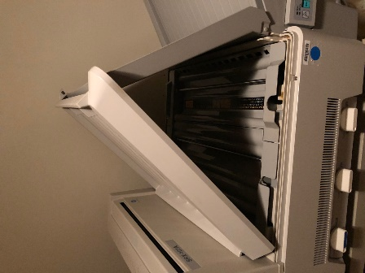

## In Physics

1. Use a pen and straightedge to draw a straight line through the middle of each black line on the film.
2. Evaluate the test results. If all drawn lines cross within a millimeter of each other, the test passes. Otherwise, the test fails.

# Solid Water Setup for Each Starshot Test

## Gantry

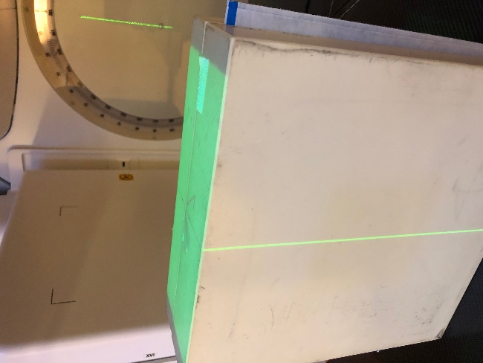

## Couch

